# Exercise 1: To visualise wind power potential and aspects that relate to wind energy utilisation in a country of your choice.

## Objective:

To visualize wind power potential and aspects that relate to wind energy utilization in India.

|  |  |
| --- | --- |
|  | Data Source: **Download Wind Data**: Energy Data Info  **Content of Data**: Wind Speed and Power Density Method: First step is to data Importing. Second step is data analysis by using histograms to categorize wind speed. Next step is to categories to Wind Speed and Power Density [See Fig 1.1]. |
| **Figure 1.1: Average Wind Speed and Power density at a Hight of 100 m** |  |

## Results:

The classification of wind speed and power density provided a clear representation of wind energy potential. The analysis successfully identified regions with varying suitability for wind energy projects, aiding in strategic planning and decision-making.

# Exercise 2: Download and visualise the wind speed and power density map for Denmark.

## Objective:

To download and visualize wind speed and power density maps for Denmark.

## Method:

First step is to load data (.TIF) files for wind speed and power density.

|  |  |
| --- | --- |
|  | Second, set Coordinate System which is **ETRS89 / UTM zone 32N** (See Figure 2.1). Next step is to analyse Histogram and apply symbology for categorized wind speed and power density into classes. |
| **Figure 2.1** |  |

|  |  |
| --- | --- |
| Then next step is to add Wind Turbine Data, which is imported CSV file and reviewed its content (See Figure 2.2). Then next step is to visualize Wind Turbines to use Graduated Symbols and Unique Values to map for power capacity and manufacturers (See Figure 2.3 and 2.4). |  |
|  | **Figure 2.2** |

|  |  |
| --- | --- |
|  |  |
| **Figure 2.3** | **Figure 2.4** |

Last but not least, enhance Map Design to added grid, north arrow, and scale bar (See Figure 2.5).

## Results:

The analysis effectively visualized wind speed and power classifications, as represented in the legend. Wind turbine capacity and manufacturer distributions were mapped to provide insights into spatial patterns of wind energy infrastructure. The final outputs highlight key areas for wind energy potential while ensuring clear and informative data representation.

|  |  |
| --- | --- |
|  |  |
| **Figure 2.5** |  |

# Exercise 3: Find potential wind energy locations in County Galway, Ireland)

## Objective:

To find suitable locations for wind energy projects in County Galway, Ireland.

## Method:

First, we imported ***County_Galway.shp*** and other relevant shapefiles into QGIS, ensuring consistency by borrowing the projection from ***County_Galway.shp*** and adjusting symbology for clear visualization. Next, we identified and saved specific land areas by selecting forests from ***OSM_Landuse*** using an attribute query **(*fclass = 'forest'*)**, exporting them as a new shapefile (*All_Forest*), and identifying regions with wind power density below 900 W/m² which is See fig 3.1. To assess wind turbine placement, we used the ***Select within Distance* tool** to find turbines within 5 km of natural heritage sites (See figure 3.2). For the final step, we created a “White Map” by conducting a buffer analysis: applying 1 km buffers to forests, heritage sites, and residential areas, a 0.5 km buffer to wind turbines, and a 0.2 km buffer to main roads. These buffered areas, along with ***OSM_Landuse*** and ***Power_Density_LessThan_900***, were merged into a single layer to define no-go areas (See Figure 3.3). Finally, we applied the ***Difference* tool** to subtract restricted zones from ***County_Galway***, to find the suitable locations for wind energy projects (See Figure 3.4).

|  |  |  |
| --- | --- | --- |
|  |  | |
| **Figure 3.1** | **Figure 3.2** | |
|  | Results: The analysis successfully identified suitable wind energy locations by applying spatial queries, buffering constraints, and geoprocessing techniques. The final map highlights optimal areas while excluding environmentally and spatially restricted zones, ensuring an efficient and sustainable site selection process. |
| **Figure 3.3** |  |
|  |  | |
| **Figure 3.4** |  | |

# Exercise 4: Local Wind Farm Planning (Location: Lindewitt Municipality, Schleswig-Holstein).

## Objective:

To analyse wind energy potential in Schleswig-Holstein by categorizing goals and principles, integrating wind turbine data, and creating a wind farm development map.

## Method:

|  |  |
| --- | --- |
|  | All relevant **.shp** files were imported into QGIS, and their colours and styles were adjusted for better visualization. The layers were categorized into two groups: Principles and Goals(See Figure 4.1). |
| **Figure 4.1: All layers with principles and goals** |  |

Wind turbine data was downloaded from the official Schleswig-Holstein site (<https://opendata.schleswig-holstein.de/dataset/windkraftanlagen-2023-07-13>) and integrated into the project. To identify suitable wind farm development areas, an **800 m** buffer was created around existing wind turbines. A Difference tool was attempted between the Potential Wind Areas layer and the buffered turbine layer, but an invalid geometry error occurred. This was resolved by using *Vector → Geometry Tools → Check Validity* to fix the geometry before reattempting the operation. The final Wind Farm Development Map successfully highlights areas suitable for future wind energy development (See Figure 4.2).

**How Goals and Principles contribute to Potential wind areas around Lindewitt?** **Which goals and principles cut across potential wind areas?**

The analysis of Goals and Principles in relation to Potential Wind Areas around Lindewitt reveals distinct contributions from each category. Goals represent non-negotiable constraints, including critical layers such as residential areas, federal inland waterways, legally protected biotopes, and forest areas, which strictly limit wind energy development. In contrast, Principles are more flexible, allowing for negotiation in certain areas. Through spatial analysis, it was determined that the G02a, G05, G08, G15, G16, G21, and G24 layers from the Principles category intersect with potential wind energy zones, whereas no Goal layers were found to overlap with these areas. This distinction helps refine the selection of viable wind energy locations while ensuring compliance with environmental and legal constraints.

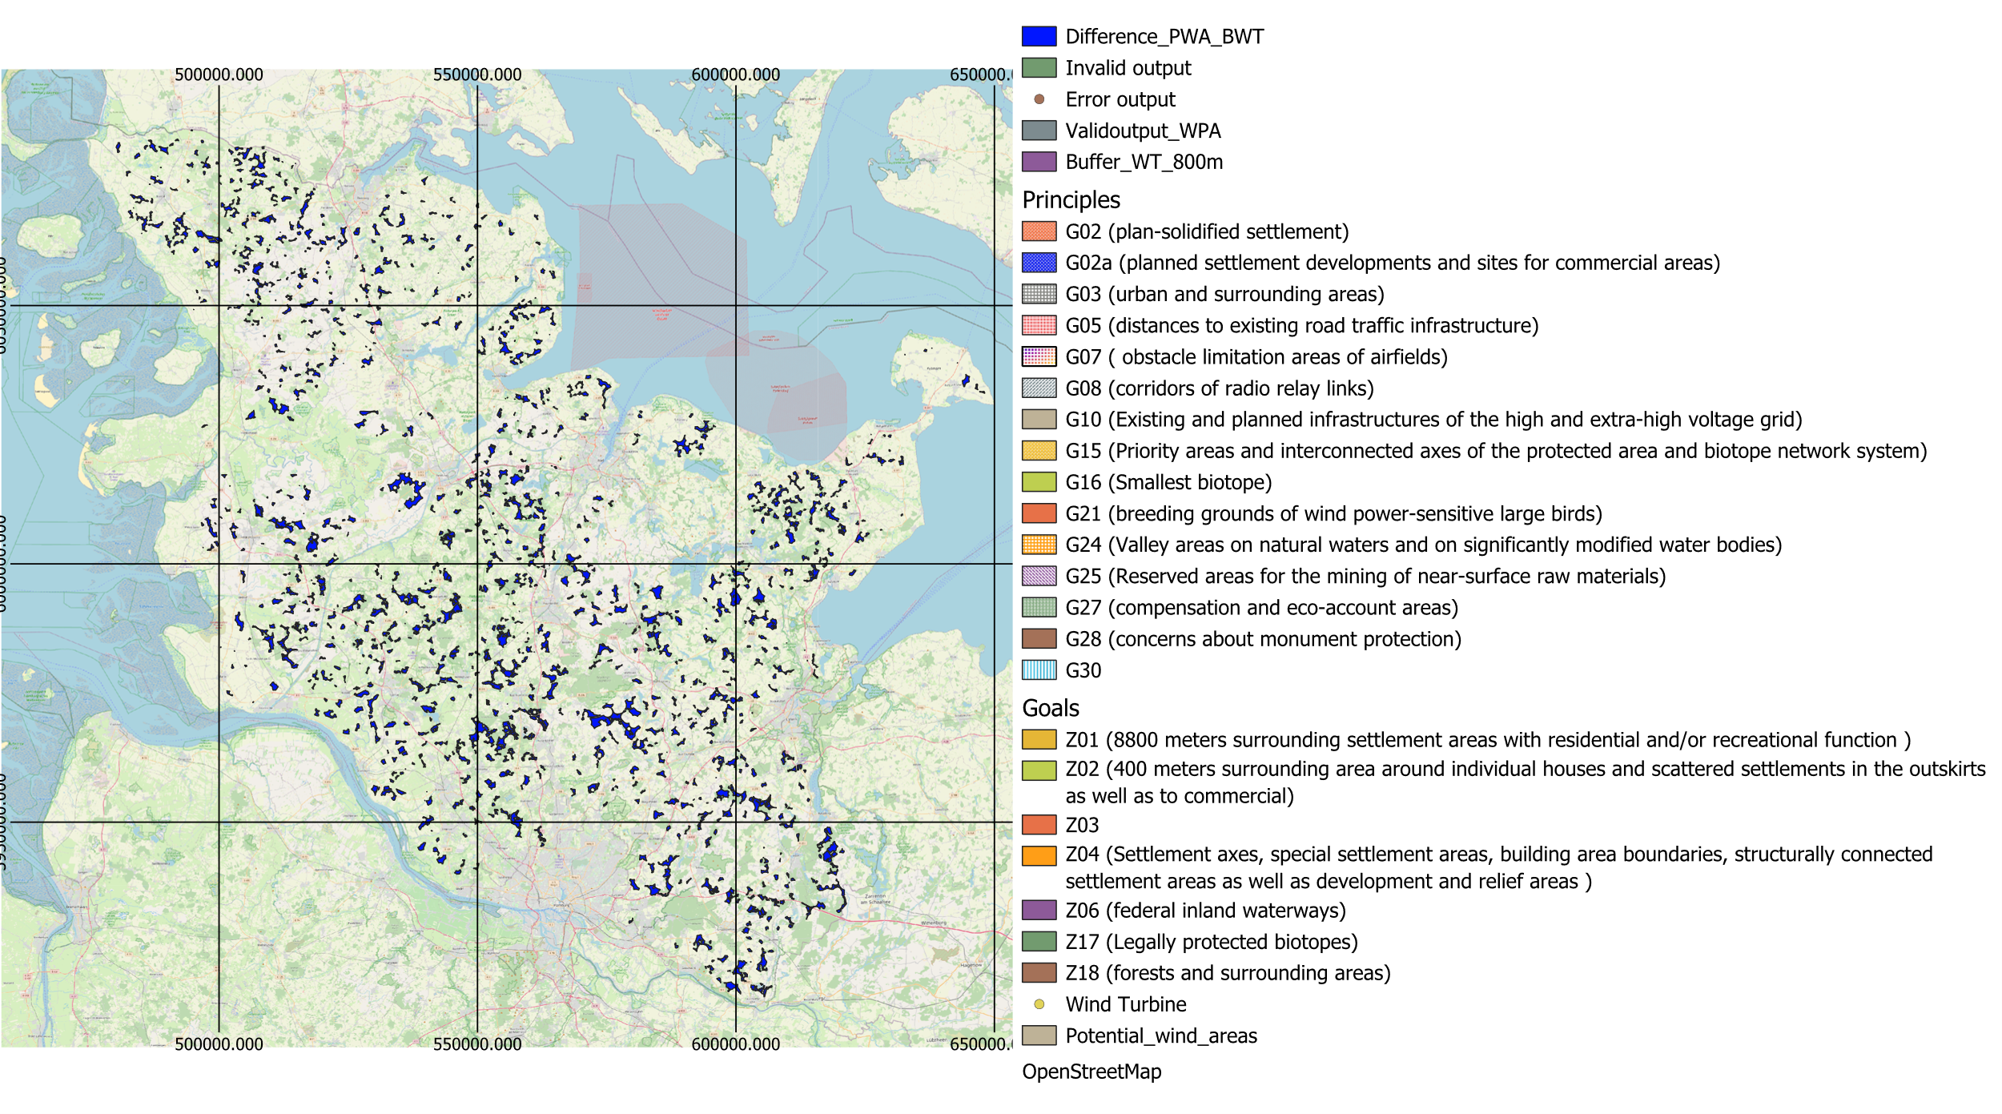

**Figure 4.2: Wind farm development map for an area without exiting wind turbines**

## Results:

The categorized Principles and Goals provided a structured approach to wind energy planning. The wind farm development map highlights suitable areas free from existing wind turbines while maintaining regulatory constraints.

# Exercise 5: Editing Points, Lines and Polygons

## Objective:

To identify and map the Wind Farm Priority Area **“PR1_NFL_036”**, integrate high-resolution imagery, and digitize essential wind energy infrastructure elements, including wind turbines, access roads, and agricultural fields within the priority area.

## Method:

The **Wind Prio Area 2020** dataset was imported from **Stud IP**, and the attribute table was queried using Select by Expression to filter for the specified priority area (**“PR1_NFL_036”**). The selected feature was then exported as a new shapefile for further analysis.

To enhance visualization, ESRI World Imagery was added as a high-resolution backdrop using either ‘’**QuickMapService’’** in QGIS or an online site, which show in below.

([https:// server.arcgisonline.com/arcgis/rest/services/World_Imagery/MapServer](https://server.arcgisonline.com/arcgis/rest/services/World_Imagery/MapServer)).

|  |  |  |
| --- | --- | --- |
|  | | For spatial mapping, a new shapefile layer was created to add wind turbine attributes. Using Toggle Editing, wind turbines were digitized by selecting Add Point Feature and placing points near existing turbines (See Fig. 5.2: Blue point). Additionally, access roads were mapped using pre-existing road data (See Fig. 5.1: Yellow Lines). |
| **Figure 5.1** | |  |
|  | Agricultural fields intersecting with the priority area (polygons). Snapping tools were utilized where necessary to ensure spatial accuracy, and attributes were added to the respective layers (See Figure 5.2). | |
| **Figure 5.2** |  | |

## Results:

The final dataset provides an accurate representation of wind farm infrastructure within the designated priority area. The wind turbine locations were successfully digitized, with access roads mapped to illustrate connectivity. The agricultural fields intersecting the priority area were also identified, helping assess land use conflicts. The integration of high-resolution imagery provided a clear geographic reference, enhancing spatial analysis and decision-making for wind farm development.

# Exercise 6: Visualise the results with colours and transparency

## Objective:

To analyse the visibility of existing wind turbines in Schleswig-Holstein using a viewshed analysis and visualize the results with appropriate colours and transparency.

## Methods:

Install Visibility Analysis Plug-In: Installed the Visibility Analysis plug-in to enable viewshed analysis in QGIS. Data Import: Loaded the SRTM3 elevation model (DSM) and existing wind turbine locations for Schleswig-Holstein. Create Viewpoints: Estimated observer height using the formula: **H [m] = hub height + 0.5 * rotor diameter.** Calculated the search radius as: **Radius = 150 x turbine height**. Added two new fields **“tot_height”** and **“radius”** to the attribute table and calculated their values. A binary viewshed analysis was performed using the Processing Toolbox → Create Viewpoints, where wind turbines were set as observer locations, and the Digital Elevation Model (DEM) box select **“DCM_ETRS_LAEA [EPSG:3035]”,** applied with a **5000 m** analysis radius and an observer height of **1.6 m**.

|  |  |
| --- | --- |
|  | The final used the **Viewshed** tool to set the **binary viewshed** as the **Observer Location** and the **DEM** as the elevation reference. Saved and processed the output, then adjusted colours and transparency for better visualization (See Fig. 6.1). |
| **Figure 6.1** |  |

## Results:

The viewshed analysis provided a binary representation of visible and non-visible areas around existing wind turbines. The visualization helped in understanding the impact of turbine height and terrain on visibility. Applying colours and transparency improved readability and provided insights into optimal locations for new wind turbines.

# Exercise 7.1: Convert (Rasterize Vector to Raster) the electric grid layer to an input raster for distance mapping. Calculate the distance from the grid in metres (r.grow.distance).

## Objective:

To convert the electric grid vector layer into a raster format and compute the distance from the grid in meters using r.grow.distance.

|  |  |
| --- | --- |
| Method: The electric grid vector layer was rasterized using the Vector to Raster tool, with a burn value of 1, a cell size of 100m, and the same projection as the grid line vector layer. The “**r.grow.distance”** tool was then applied to compute the distance from the electric grid, ensuring accurate spatial analysis. |  |
|  | **Figure 7.1** |

## Result:

The final raster output displays the computed distance from the electric grid in meters (See figure 7.1).

# Exercise 7.2: Make a simple noise map for a planned wind farm in priority area „PR1_NFL_036“

# Exercise 8.1: Offshore Wind Energy Planning in Sweden

# Exercise 8.2: Calculate AEP Per Cell and LCOE for Offshore Wind Energy Planning in Sweden